Examples of hand signals to use with your deaf dog

To get their attention | Lie down | Come here
These signs are not special or official. They are not from a book of signs. They are simply ones I made up to use with my deaf dog. It is only a very small sample. You can add to them and adapt them in whatever way you like. The main thing to bear in mind is that whatever signs you choose you must be consistent. Make a note of the signs you intend to use and maybe draw them out. Put them on the fridge door or somewhere easy to view and stick to those signs.

Stay  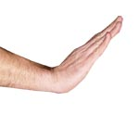 | Go in the garden / do a wee  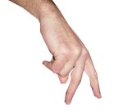 | Walkies  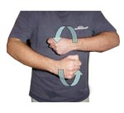

I'm going out (without you)  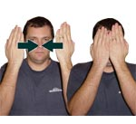 | Lets play / Get your toy  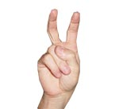 | Drop  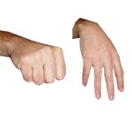

Get down  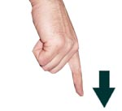 | Bring it to me  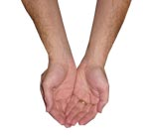 | Eat / Dinner time  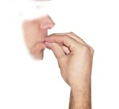

No / Naughty / Stop it  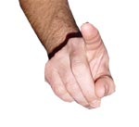 | Someone is at the door  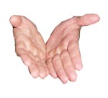 | Sit  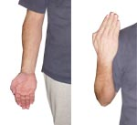

Quiet / Calm down  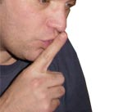 | All done / Finished  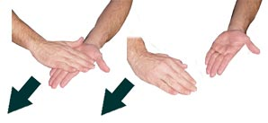

This article is strictly copyright to D for Dog © www.dfordog.co.uk
Please feel free to print these hand signals out for your own use. You can also use them when sharing information with other deaf dog owners but please credit D for Dog with the images and provide a link to us.

